Document Number | UM-64NNP-V1_REWORK1
Author | Alex Campean
Client | University of Michigan / Chestek Lab
Project | UM-64NNP-V1
Statement of Work | - Remove U16 and replace with Texas Instruments SN74LVC1G32DRYR or equivalent OR gate.  - If using hot air, a silicone cover is recommended to protect the flex circuit from damage.  - Recommended re-work settings are 275⁰C hot air, 160⁰C pre-heat, A30 (3rd to last setting) air flow.  - Cut the EMG_SCK trace going to U17, pin 6 (D Flip Flop CLRn input pin) as shown.  - Wire an Onsemi NC7SV14P5X or equivalent inverter as shown.  - Pin 2 = EMG_SCK  - Pin 3 = GND  - Pin 4 = U17 pin6 (CLRn)  - Pin 5 = DVDD

Description
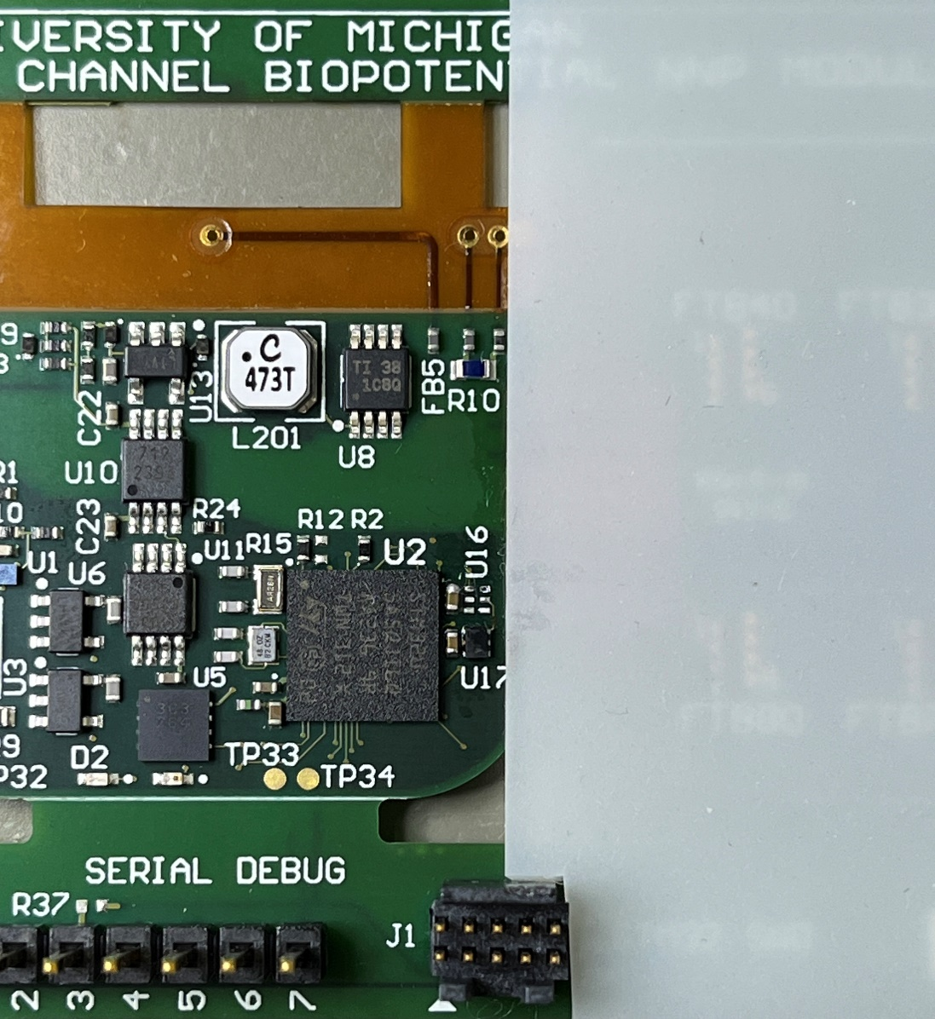
Remove U16 and replace with
SN74LVC1G32DRYR (replacement part not shown)
Silicone cover to
protect flex area.

Description
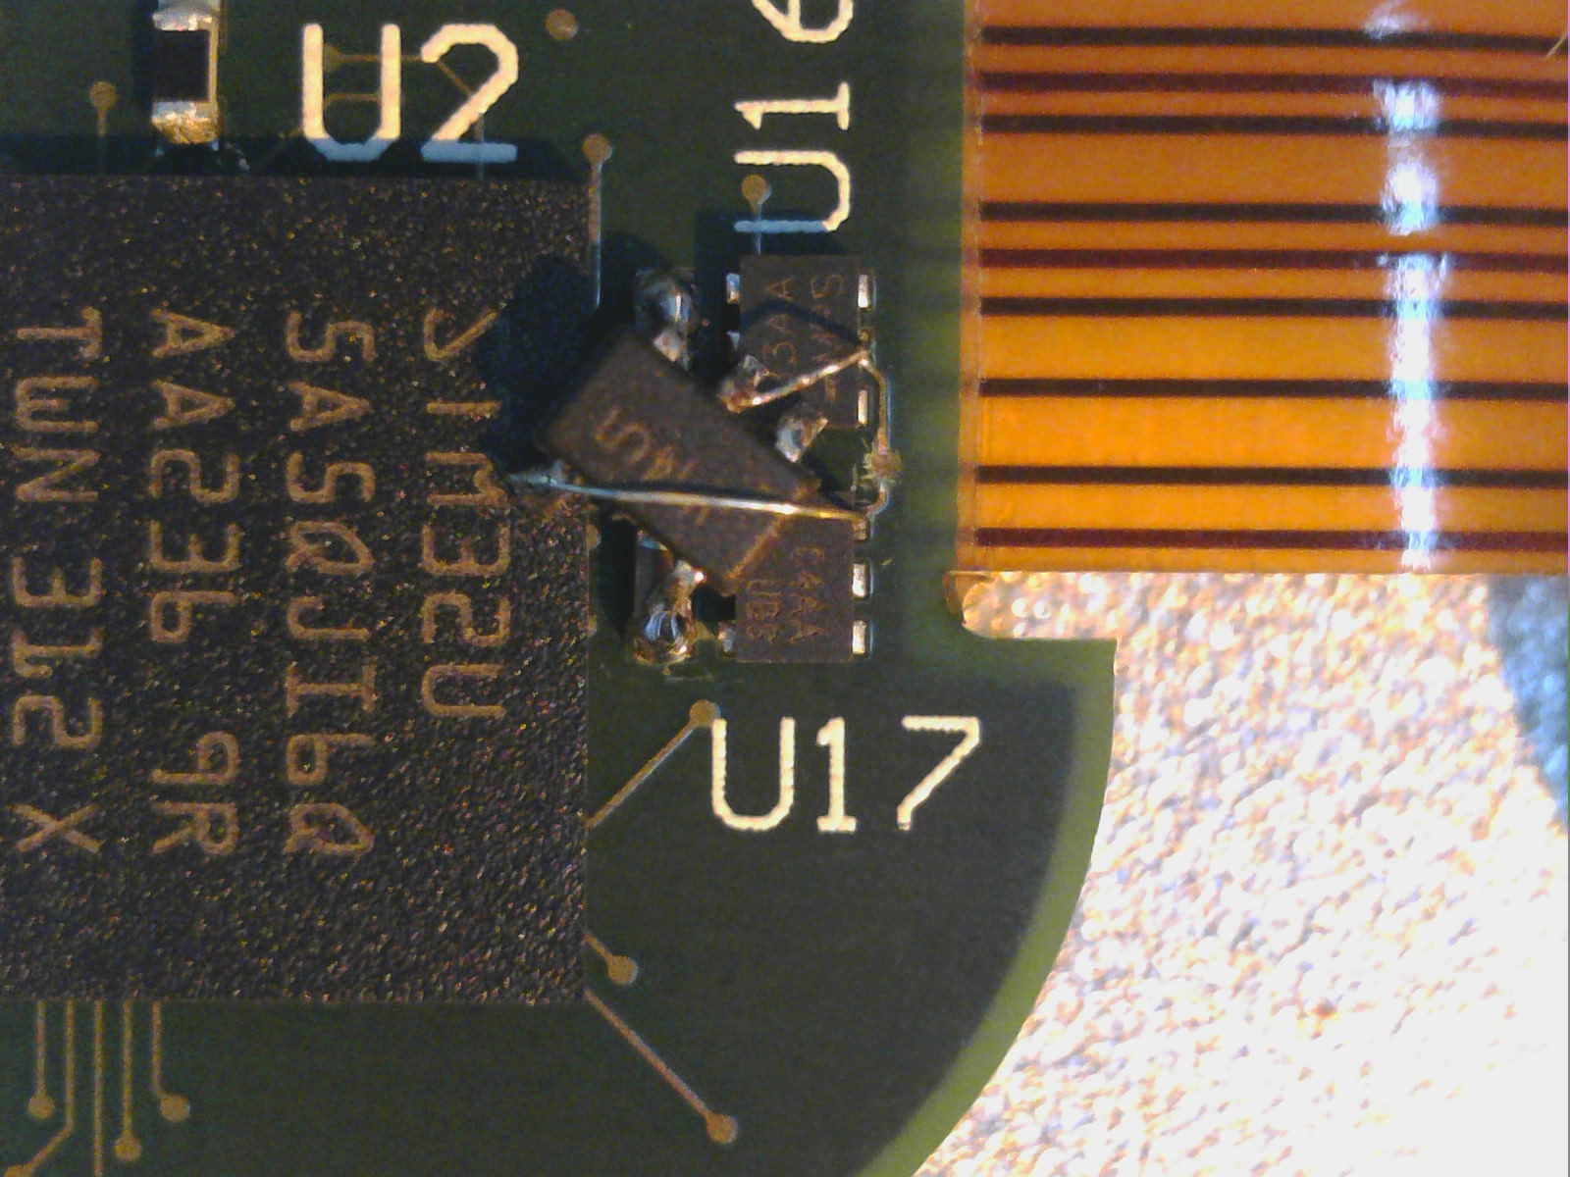
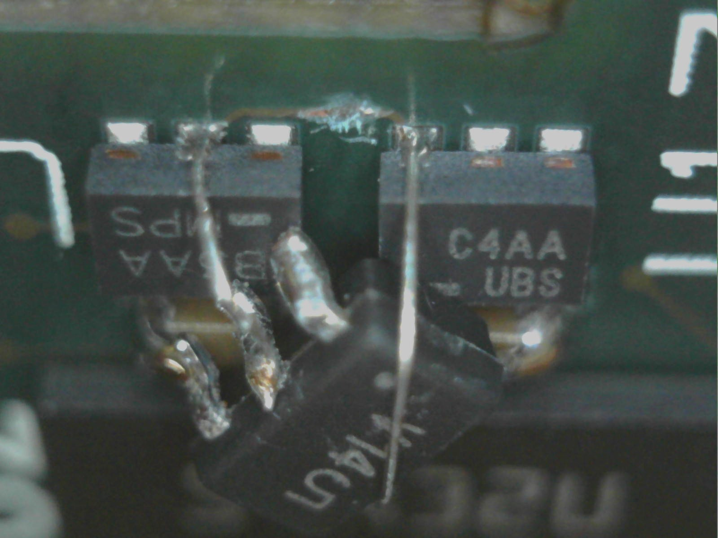
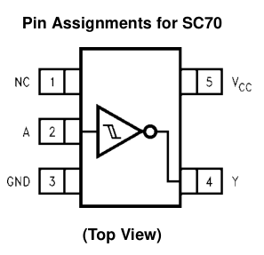
Cut EMG_SCK trace here
From: EMG_SCK
To: U17 pin6 (CLRn)
NC7SV14P5X
5 = DVDD
4 = U17 pin6 (CLRn)
3 = GND
2 = EMG_SCK
SOLDER
SOLDER
SOLDER
SOLDER
SOLDER
SOLDER

